|  |  |
| --- | --- |
| **NAME:** | BHRAMI.R.R |
| **ROLL NO:** | 18BCS056 |
| **COURSE:** | INTERNET AND WEB PROGRAMMING |
| **CODE:** | **U18CSI6201** |
| **DATE:** | 24-03-2021 |

**EXPERIMENT 4**

**EXCEPTION HANDLING**

**AIM:**

Implemention of exception handling and javascript event handling.

**PROCEDURE:**

For HTML form validation we have used ,

1.The <html> instructs the web page that the document is an HTML5 document .It is case sensitive .

2.The <head> element is a container for the tags that provide information about the document,for example <title> tag defines the title of the document.

3.The HTML <script> tag is used to define a client-side script (JavaScript).The <script> element either contains script statements, or it points to an external script file through the src attribute.

4.The <body>element contains the documents actual content .inside the body element

* we are calling validateform() to validate data when an submit event is occurring.
* In the form validation code ,
* To validate the password ,the password must contain at least 6 characters long.

5.When the data form validation is correct the screen will show successfully submitted.

**SOURCE CODE:**

<!DOCTYPE html>  
<html>  
<head>  
<title>Sample</title>  
<script>  
function validateForm()  
{  
 var fn = document.myform.FN.value;  
 var ln = document.myform.LN.value;  
 var pw = document.myform.password.value;  
if(fn == null || fn == "")  
{  
alert("Enter valide first name");  
return false;  
}  
else if(ln == null || ln == "")  
{  
alert("Enter valide last name");  
return false;  
}  
else if(pw.length<6)  
{    
alert("Enter a longer password!");  
return false;    
}  
}  
 function submit()  
{  
               alert("Submitted Successfully!");  
            }  
function over()  
{  
               alert ("Mouse Over done!");  
            }  
  
function out()  
{  
               alert ("Mouse moved out!");  
            }  
function drag()  
{  
alert("Dragged succesfully!");  
}  
             
</script>  
</head>  
<body>  
<h2><u>ONSUBMIT</u><h2>  
<h4>Welcome to Login Page</h4>  
<form name="myform" onsubmit="return validateForm()" method="post">  
<div id="1">  
<label for="FN">First Name: </label>  
<input type="text" name="FN">  
<label for="LN">Last Name: </label>  
<input type="text" name="LN">  
</div>  
<div>  
<label for="email">E-mail ID: </label>  
<input type="email" name="email" placeholder="bhrami@gmail.com">  
<label for="password">Password: </label>  
<input type="password" name="password">  
</div>  
<div>  
<label for="city">CITY: </label>  
<input type="text" name="city" placeholder="namakkal">  
<label for="state">STATE: </label>  
<input type="text" name="state" placeholder="TamilNadu">  
</div>  
<hr>  
<div>  
<input type="checkbox" name="agree" required>  
<label for="agree">I agree to all the terms and conditions</label>    
</div>  
<div onundo="undo()">  
</div>  
<button name="Submit">Submit</button>  
</div>  
</form>  
<h2><u>ONCLICK</u></h2>  
    <input type = "button" onclick = "submit()" value = "Click!">  
<hr>  
<h2><u>ONMOUSEOVER</u></h2>  
<h4>Bring your mouse on "over" to see!</h4>        
      <div onmouseover = "over()">  
         <h3> OVER </h3>  
      </div>  
<hr>    
<h2><u>ONDRAGOVER</u></h2>  
<h4>Drag your mouse on "drag" to see!</h4>  
<div ondragover = "drag()">  
<h3> DRAG </h3>  
</div>  
  
<hr>    
<h2><u>ONMOUSEOUT</u></h2>  
<h4>Get your mouse out!</h4>  
<div onmouseout = "out()">  
<h3> OUT </h3>  
</div>  
</body>  
</html>

**OUTPUT:**

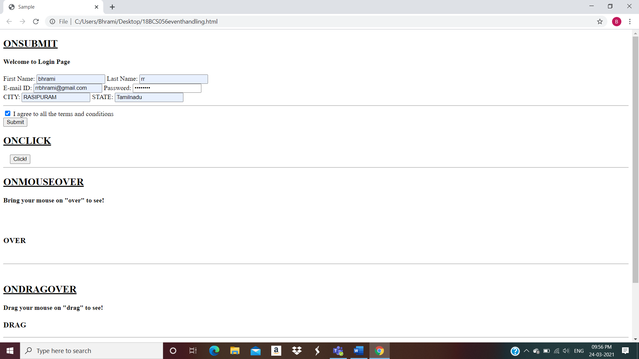

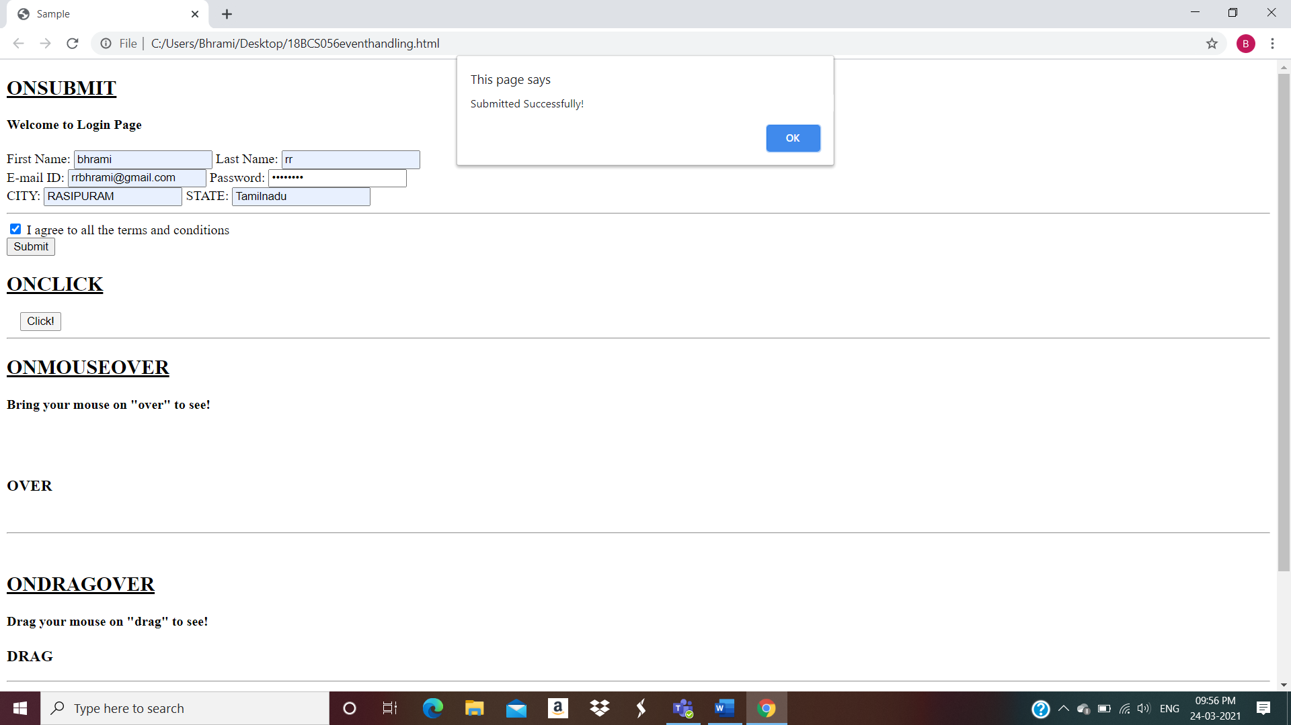

**RESULT:**

. Implemention of exception handling and javascript event handling is exceuted.